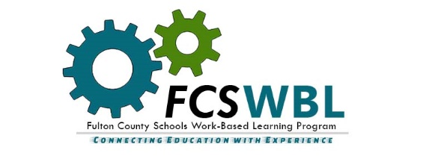

Parent/Guardian Consent Form

Transportation Consent: I understand that school-provided transportation to the work-based learning (“WBL”) worksite is not available. I give my student permission to drive/carpool to the assigned worksite. I expressly release the WBL employer and the Fulton County School System and any agents, representatives, or employees of the WBL employer or the school system from any liability that may result from my student’s use of his/her individual transportation.

Field Trips/Class Projects: I grant my permission for my student to participate in field trips and class projects associated with work-based learning. Transportation to work-related field trips will be provided by the school system.

Photo/Media Release: I grant my permission to FCS to photograph/videotape/interview my student for educational purposes.

Treatment Consent: I authorize FCS or the WBL employer to secure emergency medical treatment for my student. I understand that I will be responsible for all medical expenses incurred by my student.

Insurance: I agree to maintain health and automobile insurance for my student at my or my student’s expense that covers the student’s person while participating in the WBL program. If my student is not currently covered by medical insurance, I agree to purchase insurance through the school insurance program.

Screening for Illegal Substance Use: I understand that some WBL employers may require my student as a prospective employee to participate in drug screening procedures as a condition of employment.

*NEW* COVID-19 is an extremely contagious virus that spreads easily through person-to-person contact. Contracting COVID-19 can lead to severe illness, personal injury, permanent disability, and death. Contracting COVID-19 is an inherent risk anytime my student is present in a public place where other people are present. By signing this form and choosing to participate in the FCS WBL Program, I acknowledge and assume all risks on my student’s behalf of my student’s participation and understand that my student’s participation may increase the risk of contracting COVID-19 by my student, my family, or myself.

Release and Hold Harmless: I understand and agree that participation in the FCS WBL Program is voluntary and optional, and that I knowingly assume all the risks detailed above of my student’s participation. I release and hold harmless Fulton County Schools, the Fulton County Board of Education, FCS employees, the WBL employer, and its employees of any and all liability related to my student’s participation in the WBL Program.

I understand and agree to all of the above information and requirements.

________________________________ ________________________________

Parent’s/Guardian’s Signature & Date Student’s Signature & Date

